

**2020-2021 Spring Semester**

**Project Report**

**Course: CS223-01**

**Name: Alper**

**Surname: Mumcular**

**Student ID: 21902740**

**Lab: Project**

**Date: 6 May 2021**

**Trainer Pack: 19**

**A) Controller HLSM Diagram**

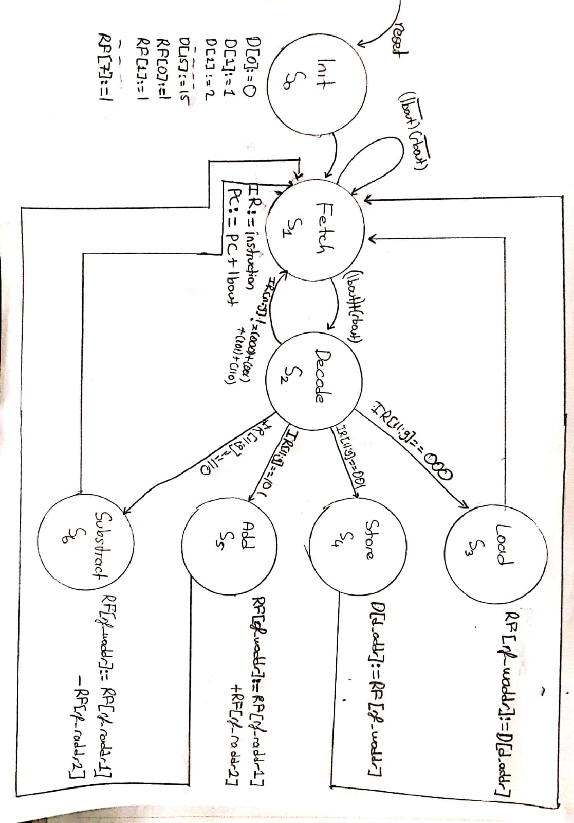

**Figure 1: Controller HLSM Diagram**

**B) Controller Block Diagram**

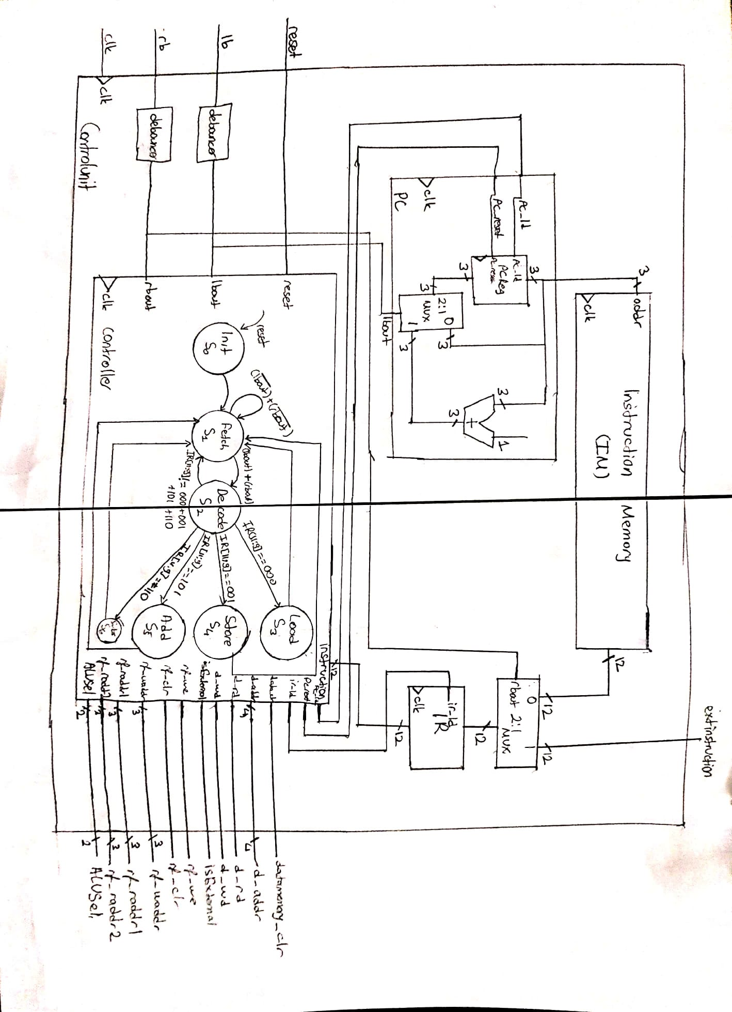

**Figure 2: Controller Block Diagram**

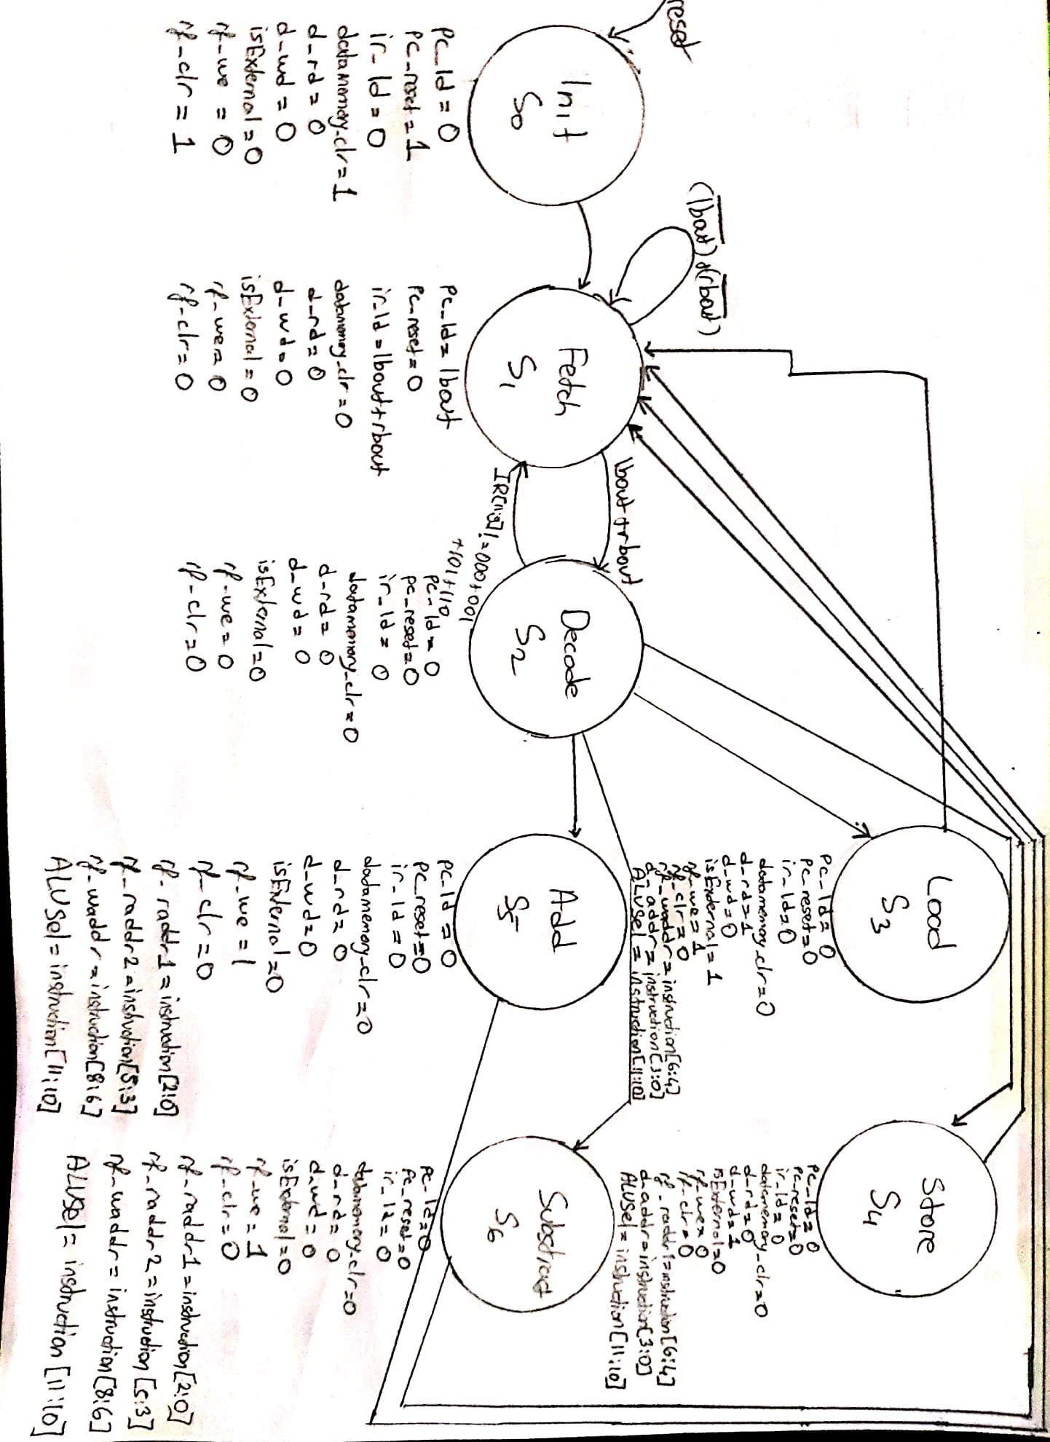

**Figure 3: Controller FSM**

**C) Controller/ Datapath Top Module Block Diagram**

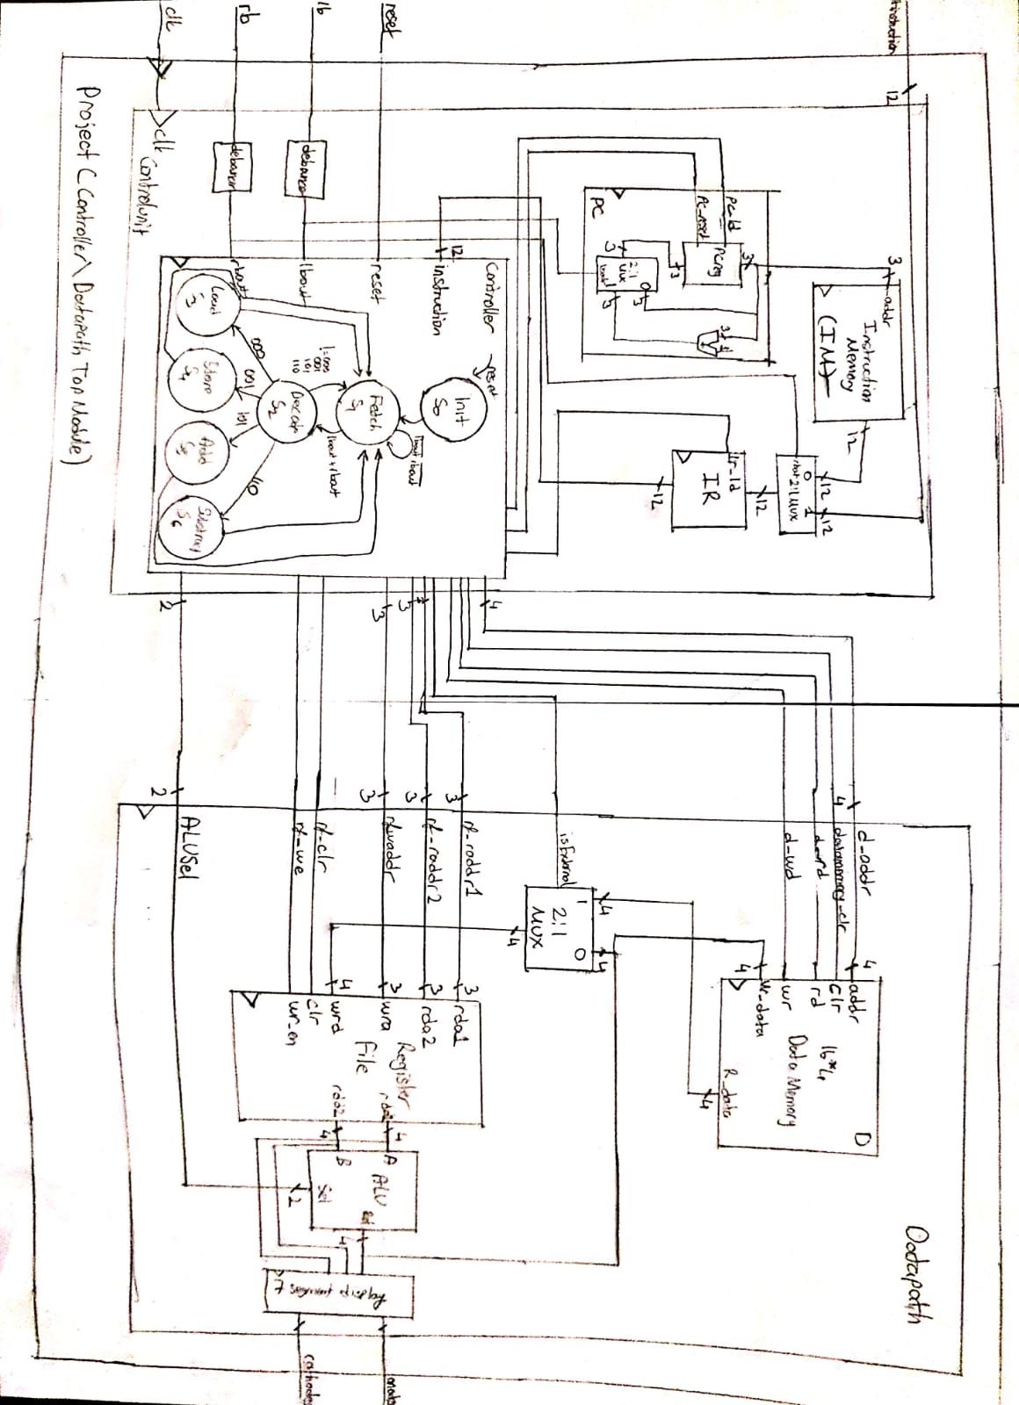

**Figure 4: Controller/ Datapath Top Module Block Diagram**